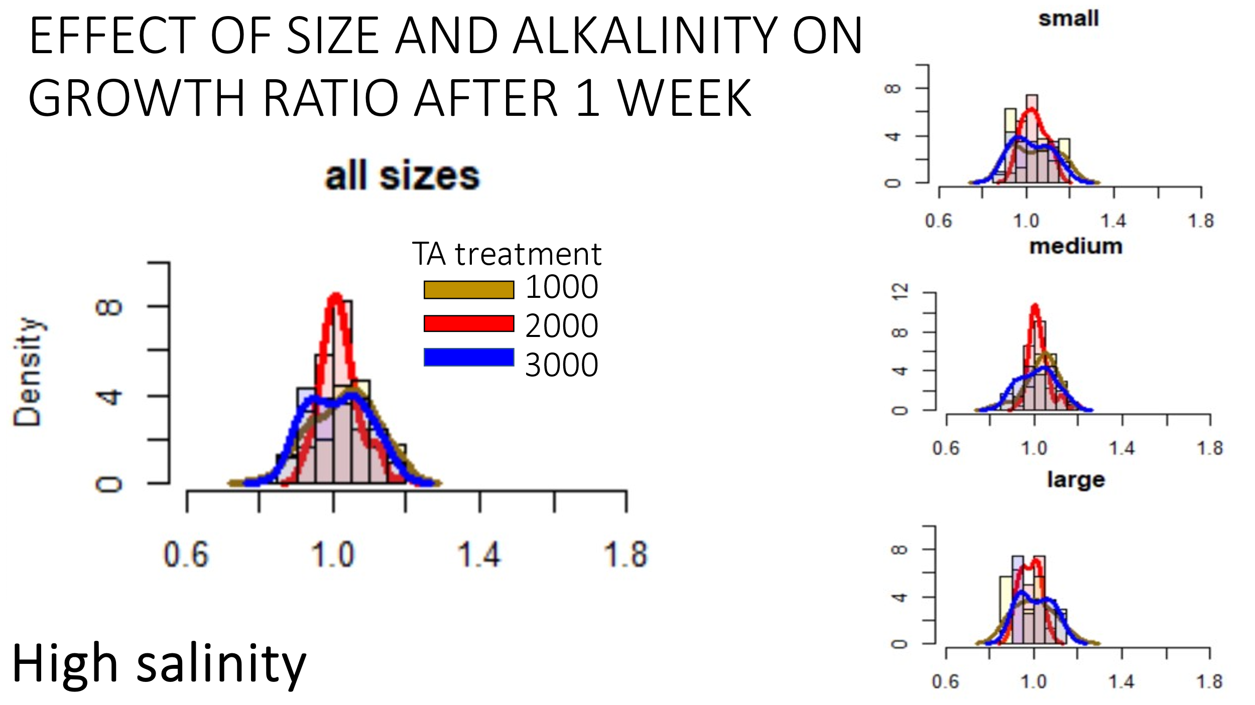

**Takeaway**: there is a “shock effect” of high TA influx or depletion to TA (1000) are not seen in individuals exposed to control TA levels (2000). Individual growth rates are not yet responding to differences in TA.

**Evidence**/**Observation**: Mean ratio between treatments and size groups appear similar and are centered around 1.0 (ie no overall growth), however, the distribution widths of the low TA and high TA are much wider, meaning outliers are less frequent than in mid TA treatment.

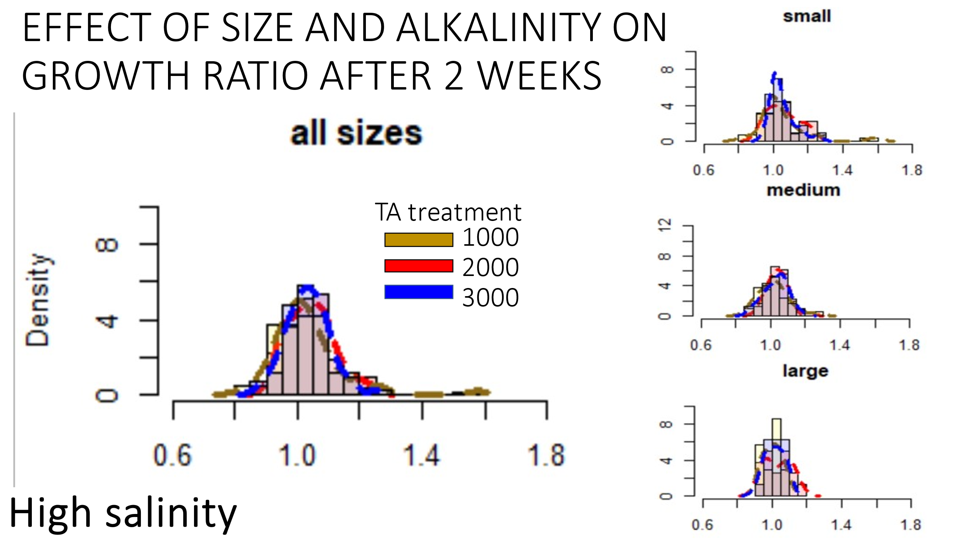

**Takeaway**: after two weeks, individuals have acclimated to each of the TA treatments, such that, there is no difference in growth ratio among the three TA levels. There are hints of differentiation in growth rate by TA treatment, though not significantly different.

**Evidence**/**Observation**: After two weeks, the distribution widths appear converge into a similar distribution among the TA treatments. This suggests that after 2 weeks time, the effect of increasing/decreasing TA has similar variability with a group of oysters, shock to treatment has finished. Mean growth ratio is also minorly shifted to the right, indicating that on average, net growth has occurred since week 1, though there are individuals from each treatment that showed reductions in size (ie net dissolution).

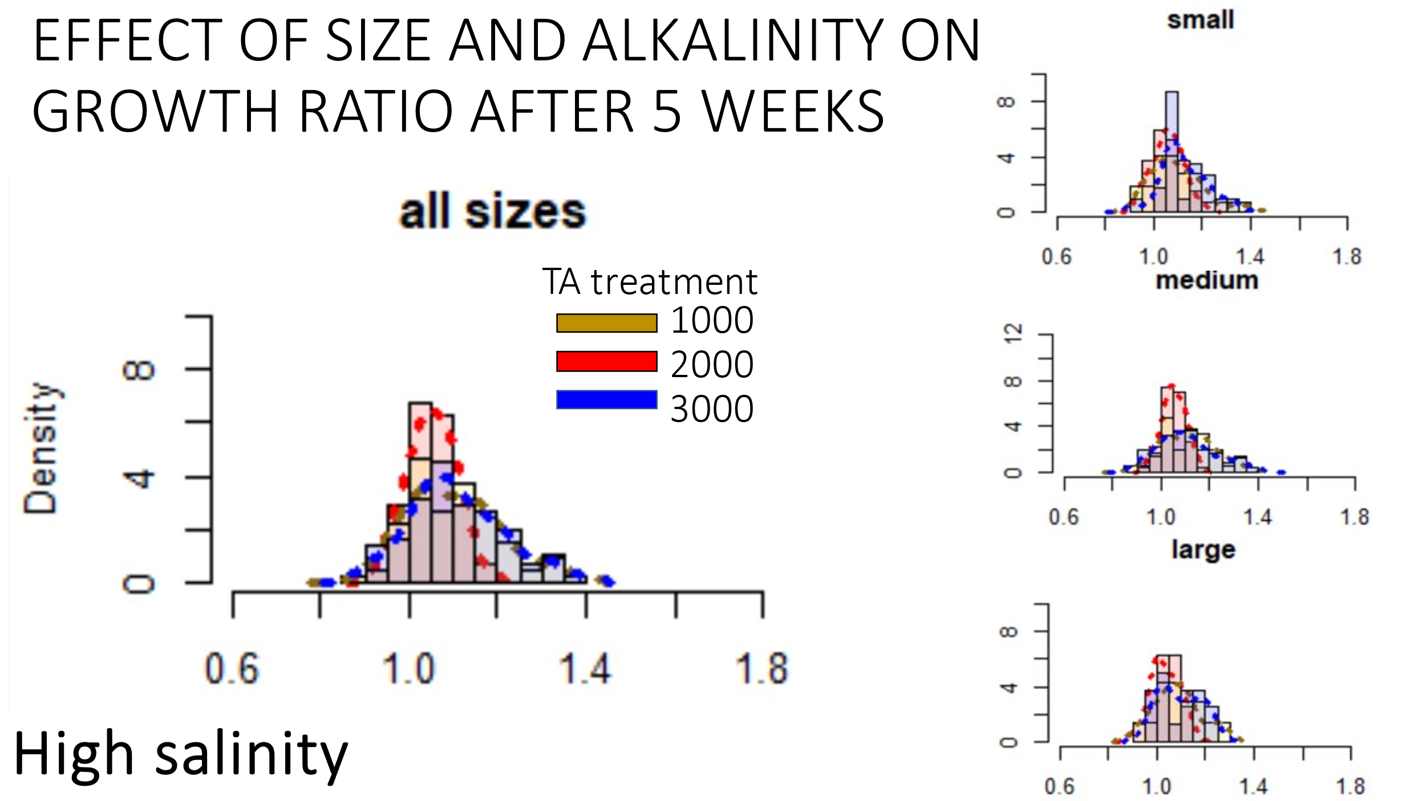

**Takeaway**: individuals grown in high Salinity environments may show more variability to initial changing carbonate chemistry, but that shock does not propagate into average growth rates by the time they are acclimated. However, individual growth rate variability increases post acclimation over time… why could that be?

**Evidence**/**Observation**: After five weeks, the distribution widths in the high and low TA treatments are much flatter, meaning that overall, changing the TA treatment has higher consequences for the variability in response from individuals than in ambient level TA. On average, at high salinity, the effect of TA does not seem to be strong after 5 weeks of growing, but as the mean value is shifted to the right, individuals did indeed grow.

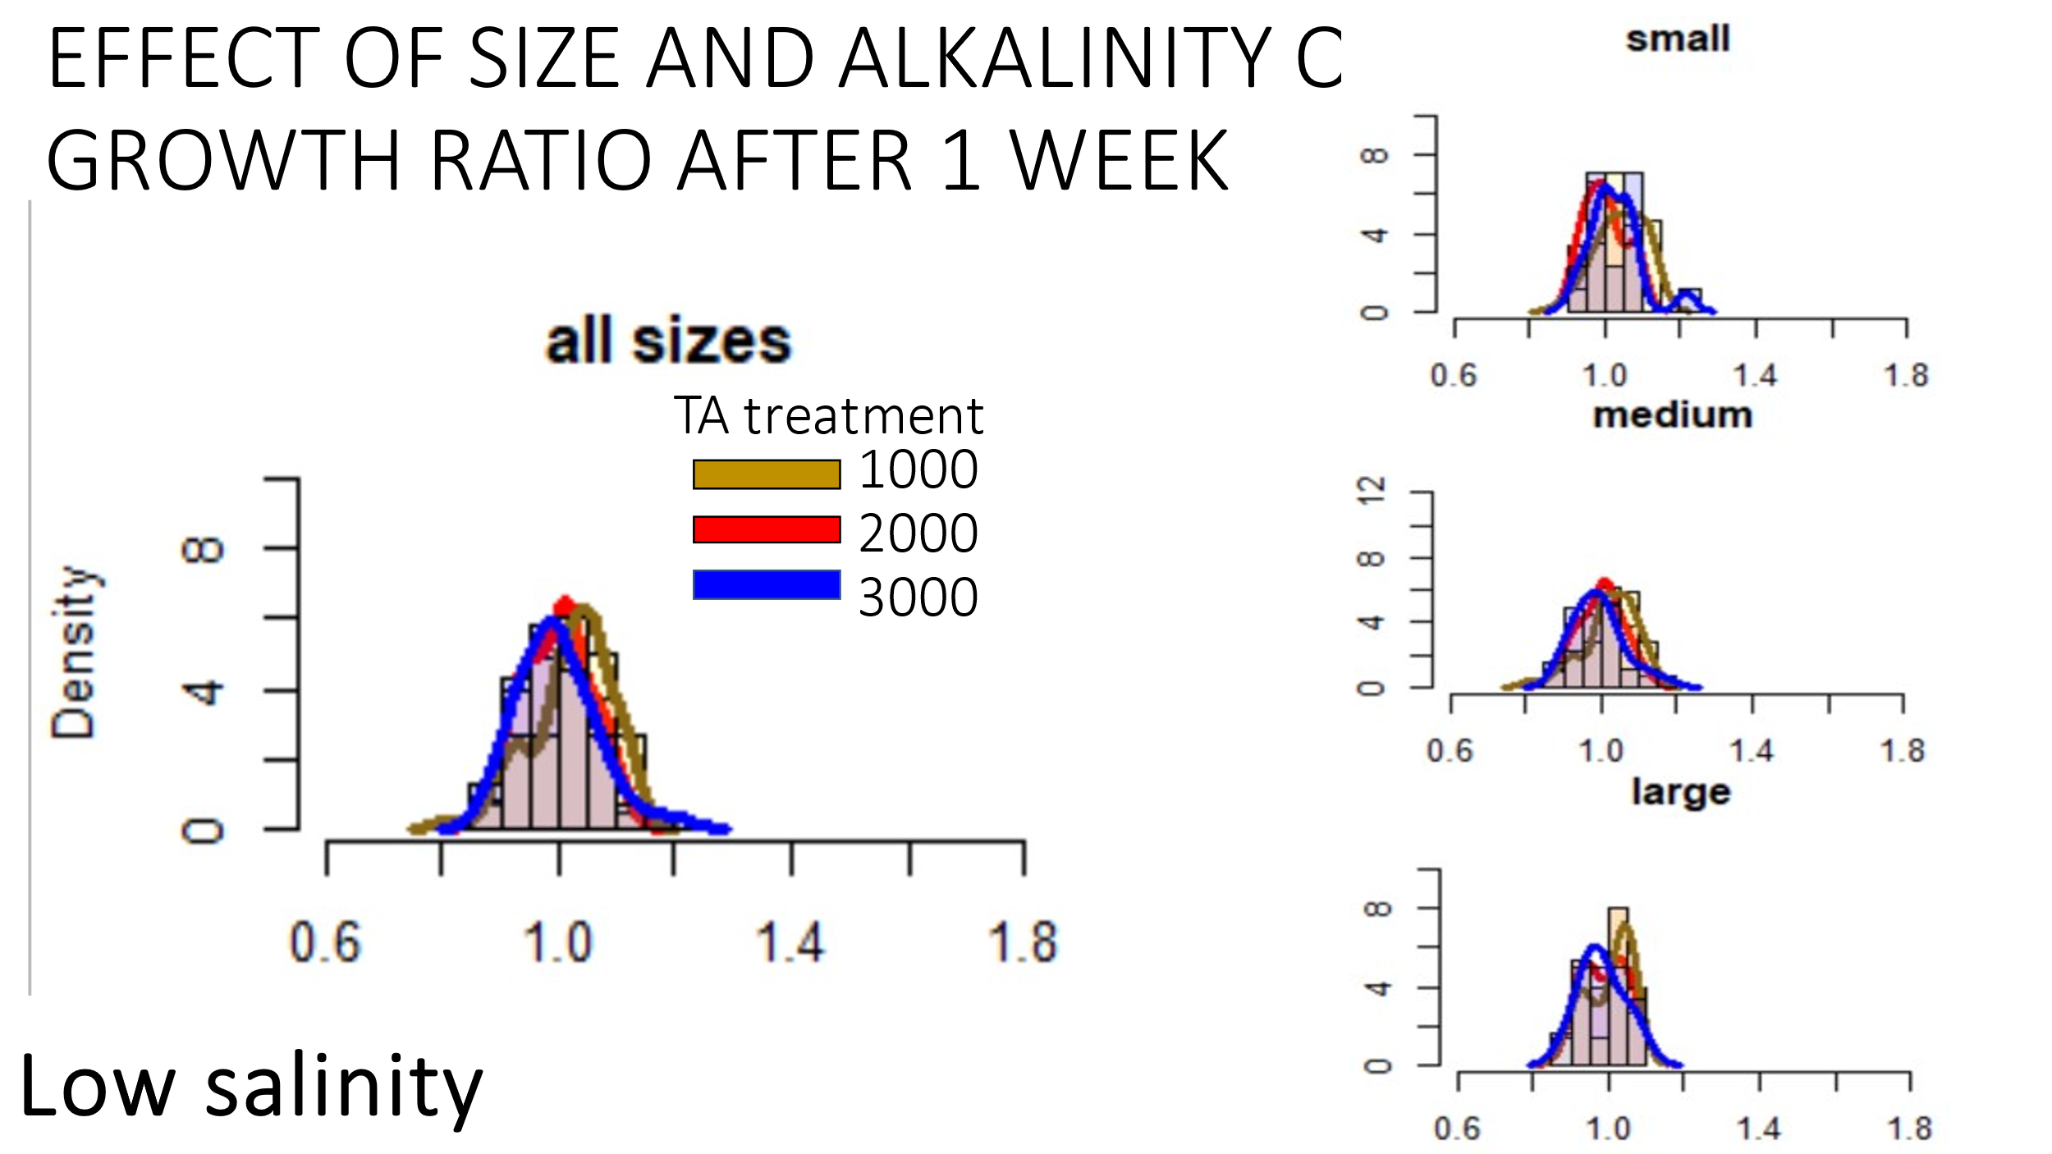

**Takeaway**: the “shock effect” of altered TA (and a combined low S shock) similarly impacts individuals, or did not occur at all (unlikely since we see shock in amb S treatments).

**Evidence**/**Observation**: Mean ratio between treatments and size groups appear similar and are centered around 1.0 (ie no overall growth), and variability among individuals within a treatment is also similar.

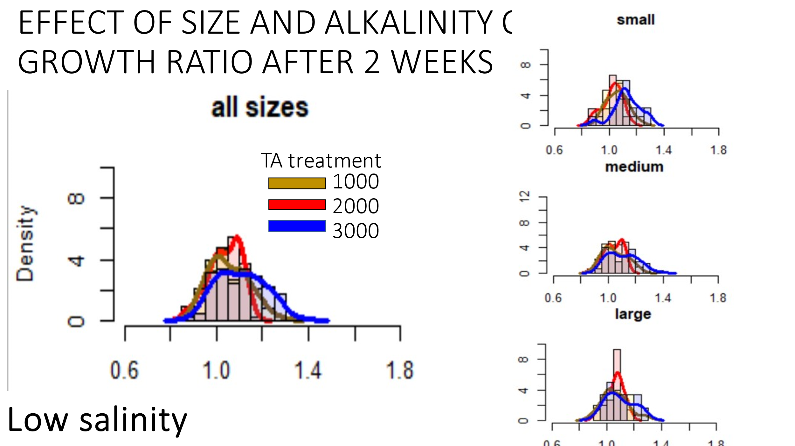

**Takeaway**: relative to 1 week patterns, individuals are not acclimating to changing TA in the same way under low S conditions. This may include having a stronger initial shock, and then a secondary shock propagating after one week.

**Evidence**/**Observation**: After two weeks, the distribution widths appear to widen for the high TA treatment but remain similar in low and ambient TA conditions, meaning that the frequency of growth outliers is higher in low and ambient TA. Mean growth may subtly be shifted to the right between low and high TA, however, ambient TA doesn’t appear to differ from either. . Low and high TA exposed individuals have higher variability in growth relative to mid TA.

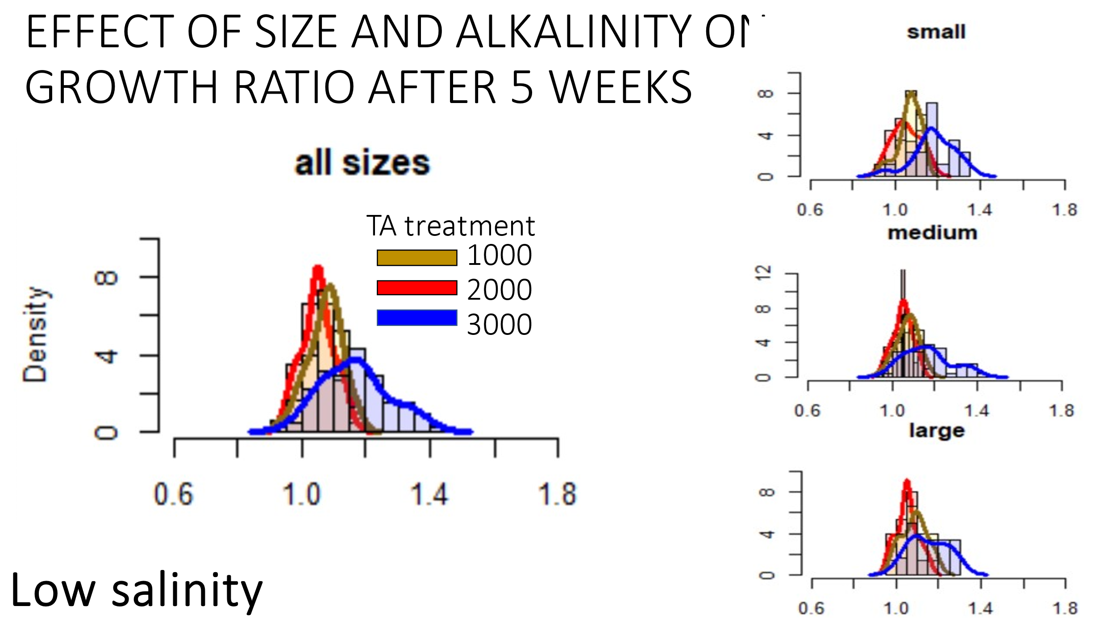

**Takeaway**: relative to the two lower TA treatments, the acclimation to high TA results on an average growth rate increase (relative to the other two), but that there will be a larger variation in the growth rates of individual oysters.

**Evidence**/**Observation**: After 5 weeks of growth, the distribution widths from the acclimation point narrow for low and moderate TA treatments but remain wide in high TA treatment. This suggests low and mid TA exposed individuals converge on a similar, consistent growth rate. High TA treatments show a right-shifted (ie increased growth ratio) and an even more flattened distribution.

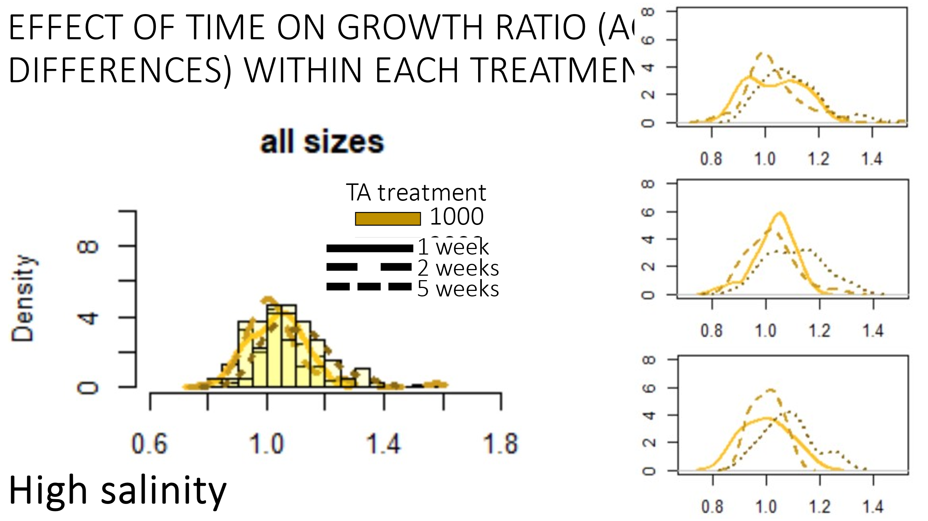

**Takeaway**: meaning negligible acclimation or small acclimation occurring over a longer period.

**Evidence**/Observation: all week lines overlap one another

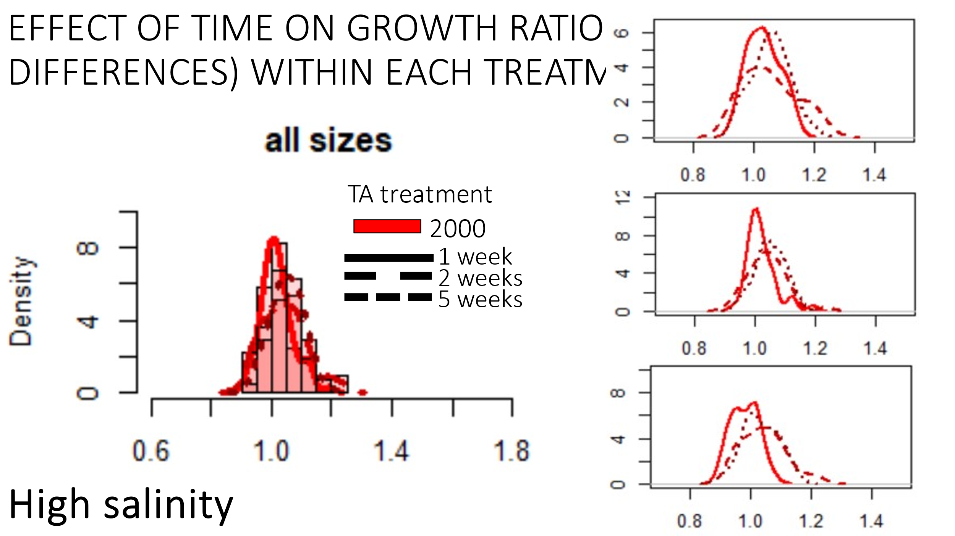

**Takeaway**: Minimal acclimation, but acclimation was fast.

**Evidence**/**Observation**: shift to the right between week 1 and week 2, fast acclimation. No difference between week 2 and week 5 meaning minimal acclimation.

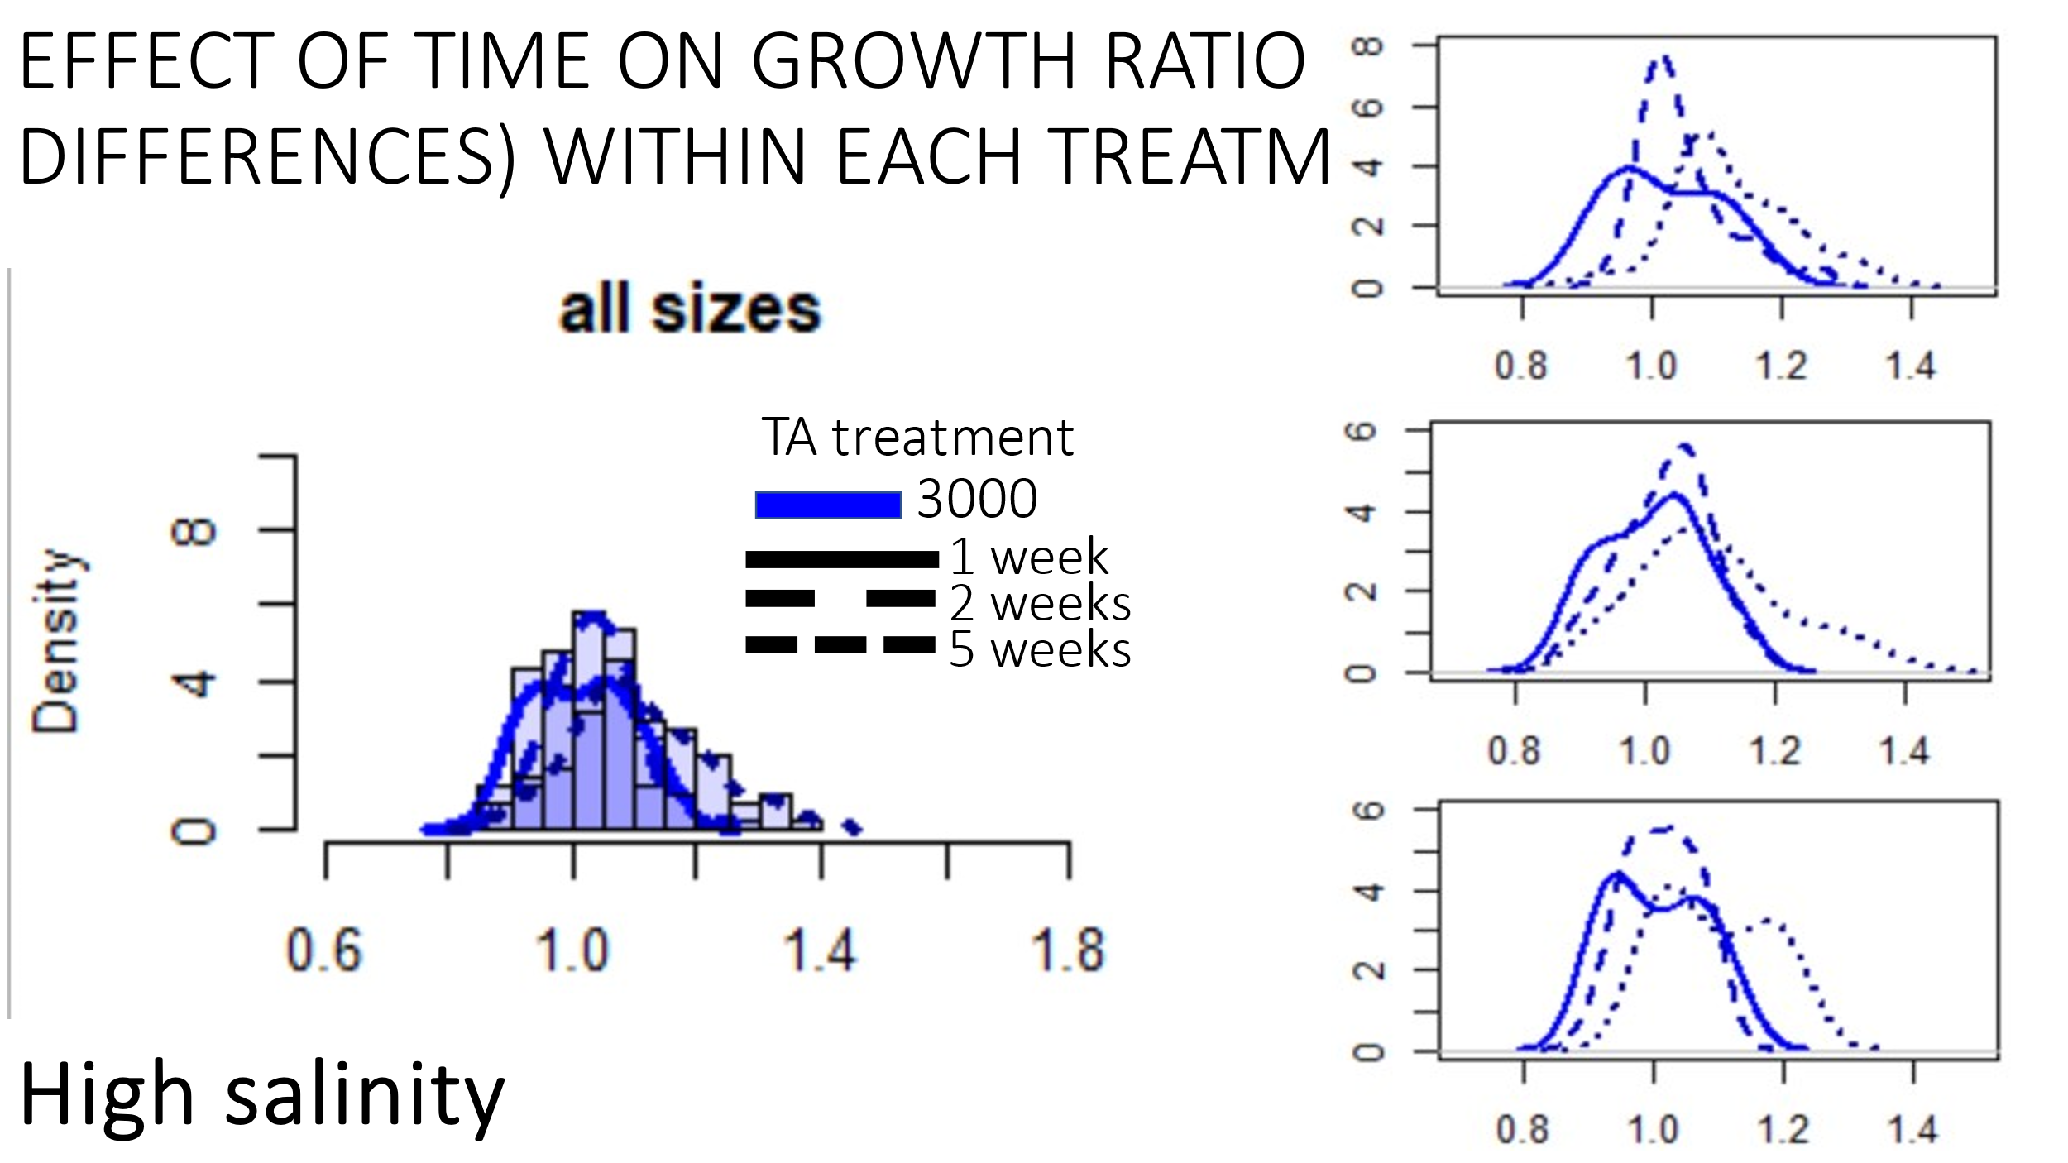

**Takeaway**: slow acclimation, second largest increase in relative growth rates

**Evidence**/**Observation**: shift to the right between week 1 and week 2 and then again between week 2 and week 5.

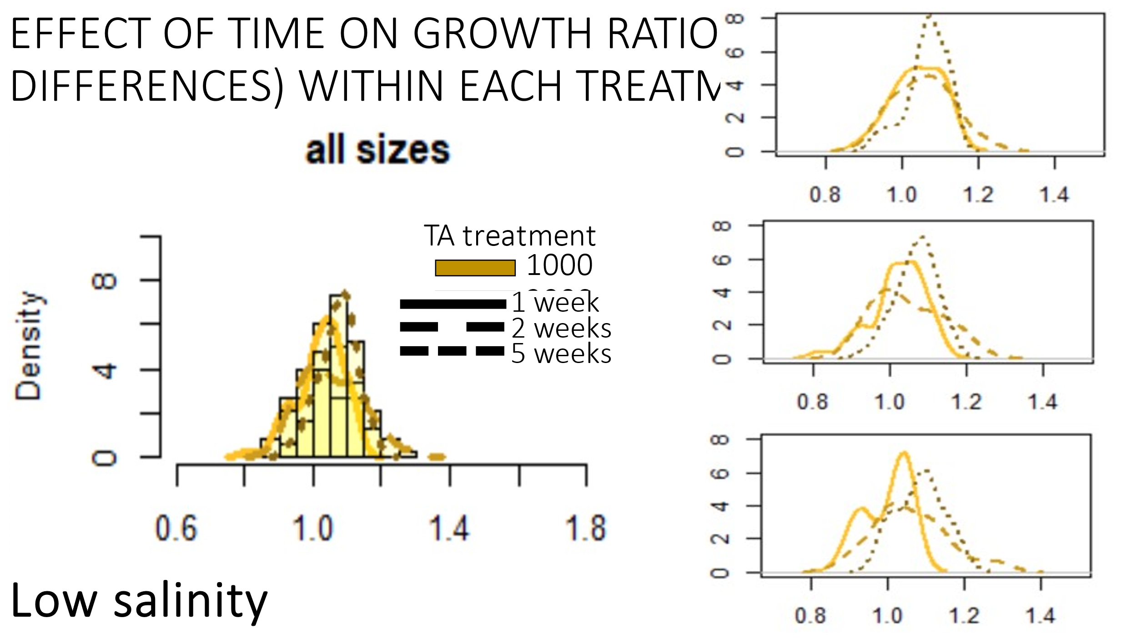

**Takeaway**: possibly a small shift to show acclimation; however, happened slowly.

**Evidence**/**Observation**: minimal shift to the right in the last week.

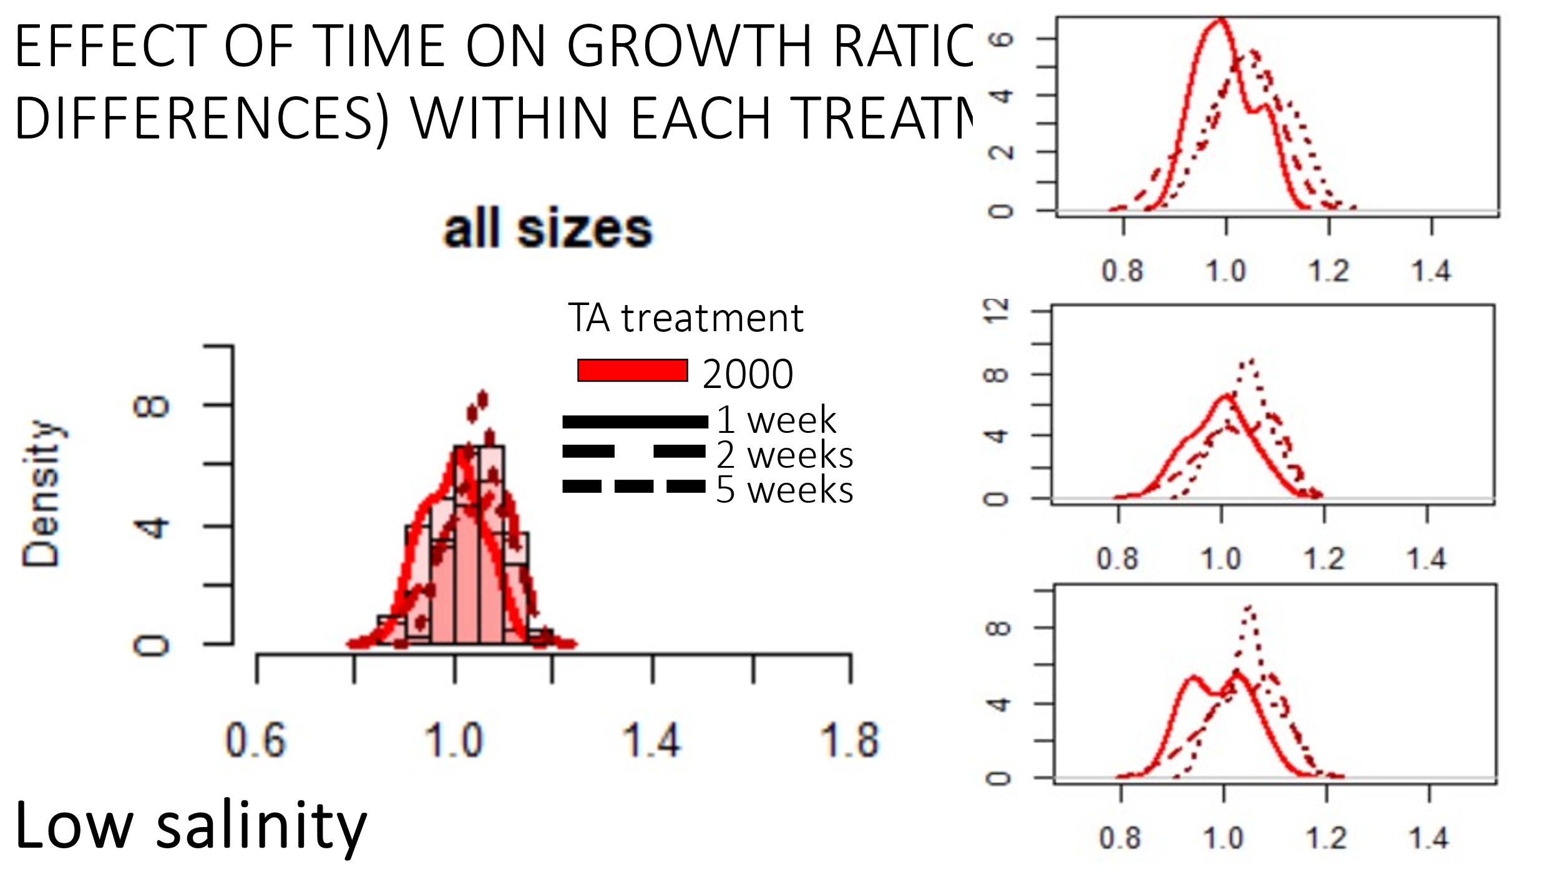

**Takeaway**: small shift in growth acclimation, however, happened quickly.

**Evidence**/**Observation**: shift in growth rate between week 1 and week 2 that was small. No shift between week 2 and week 5

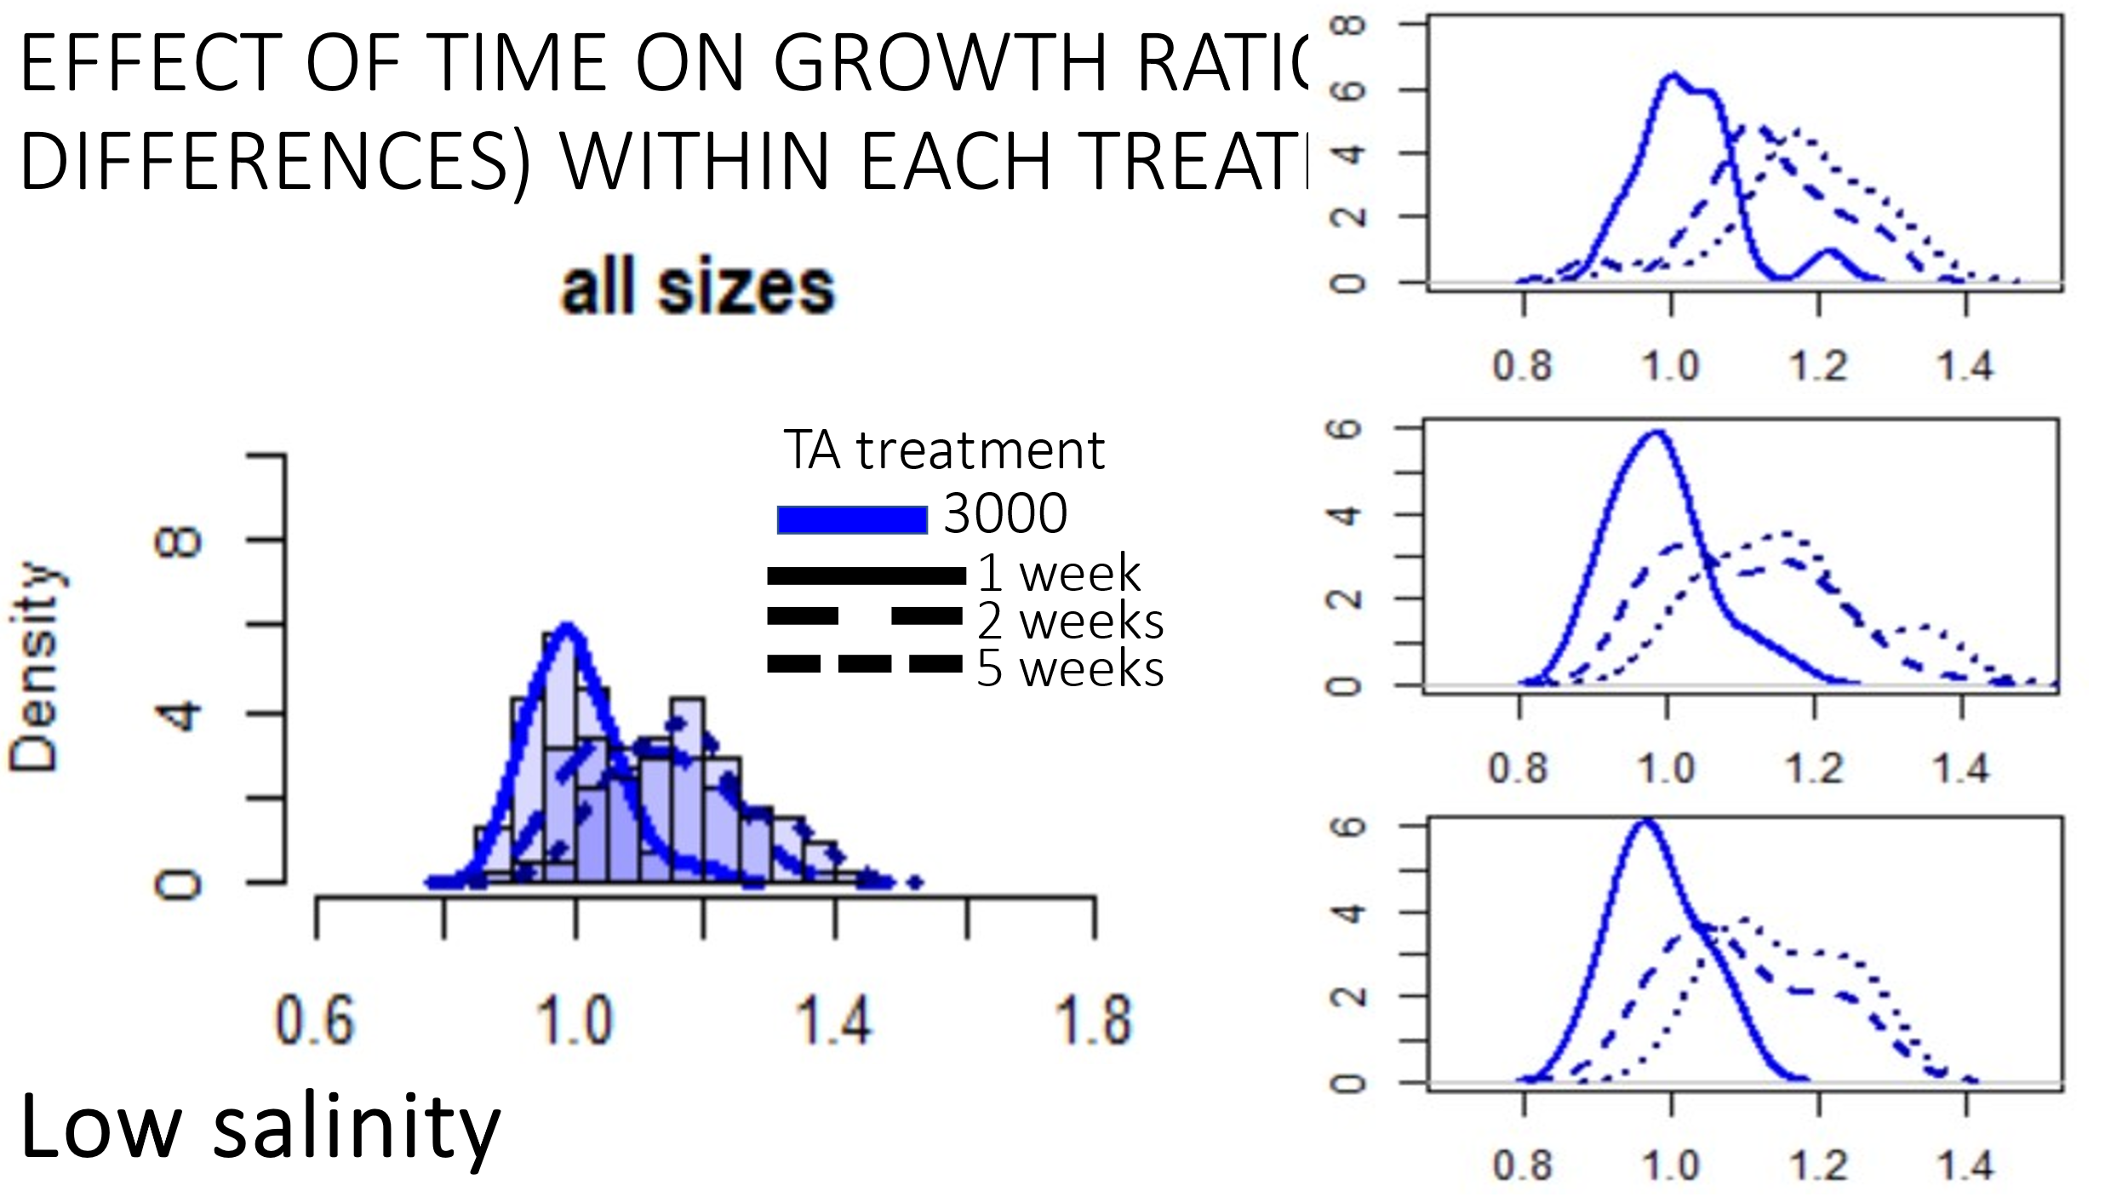

**Takeaway**: very large acclimation potential for growth rates, and further, acclimation occurs quickly.

**Evidence**/**Observation**: Large shift in growth between week 1 and week 2 and then negligible growth rate change between week 2 and week 5.

Next: I decided to look at these patterns and see how they align with changing TA or S conditions. 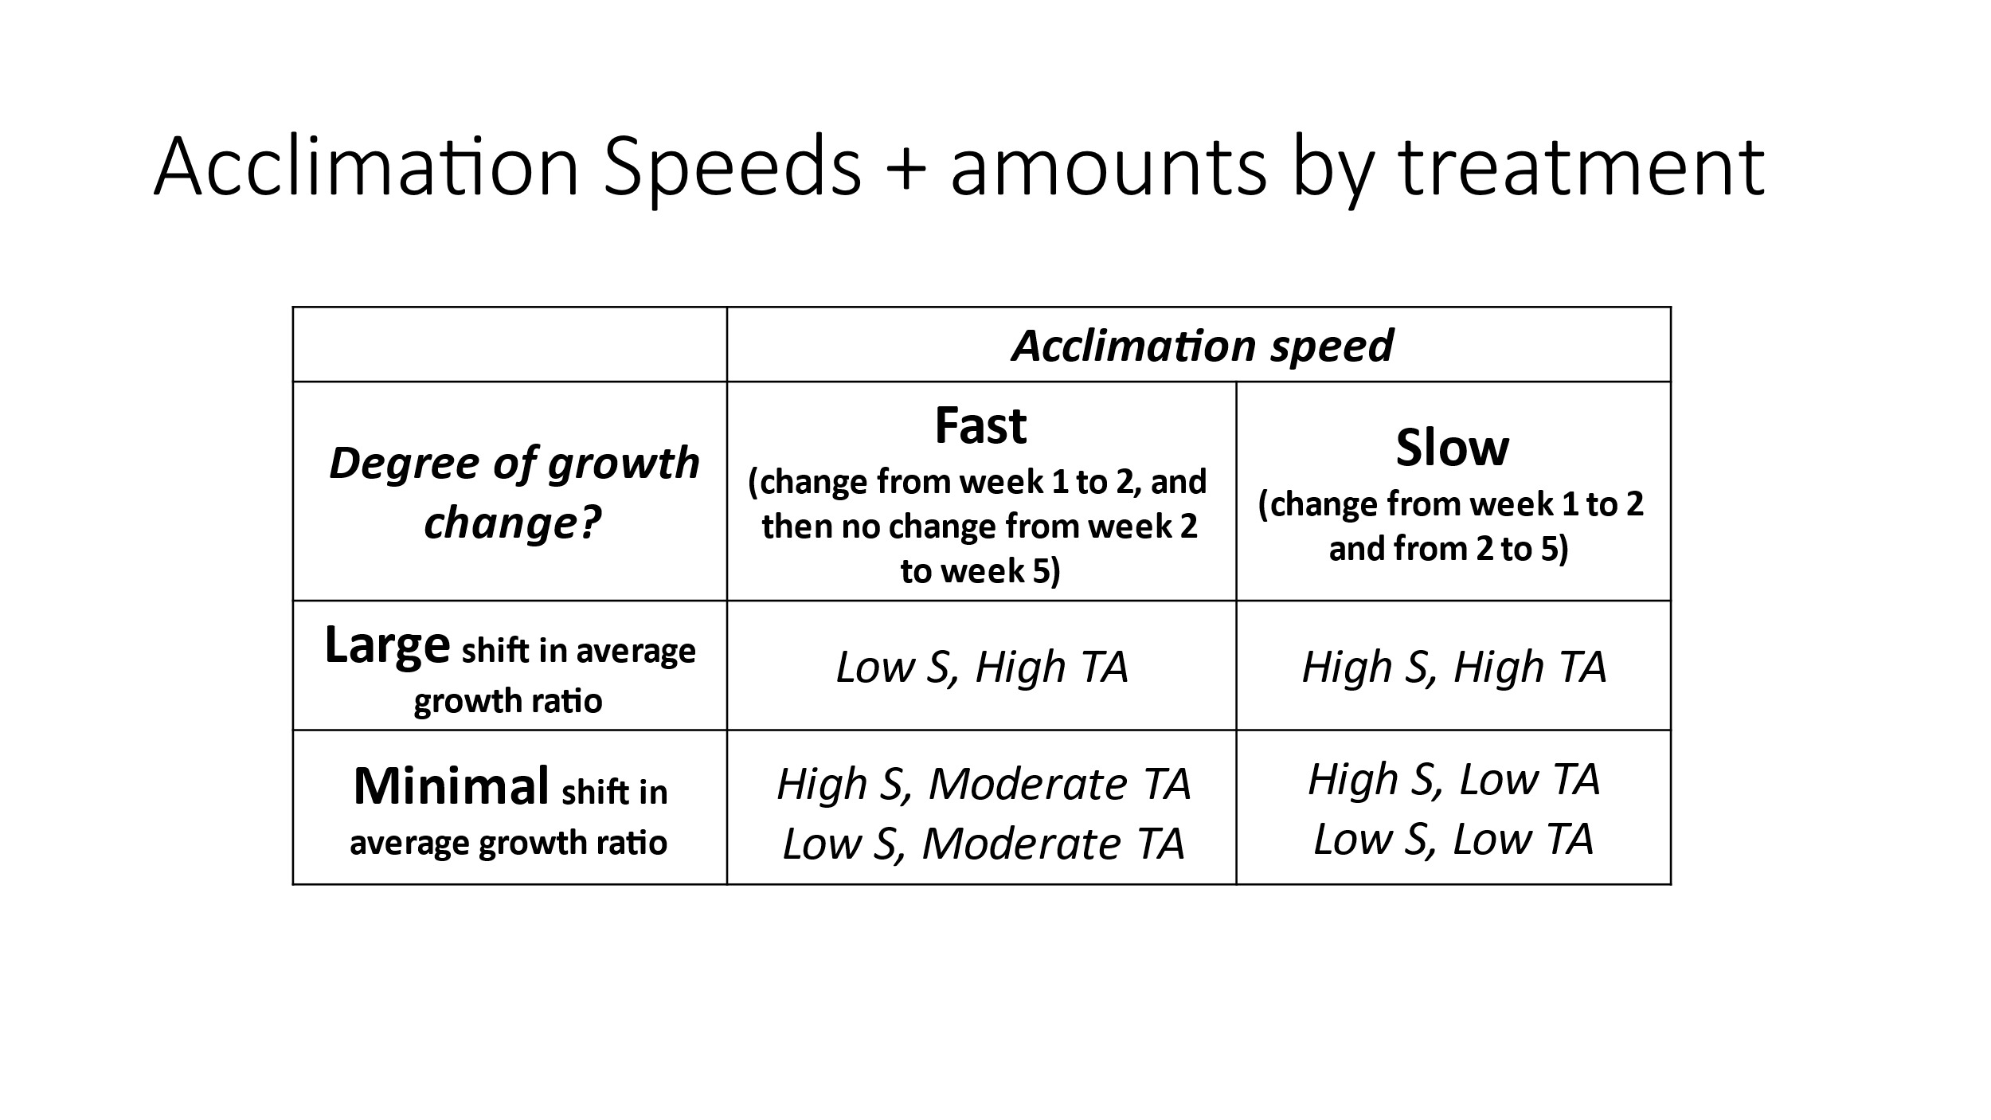

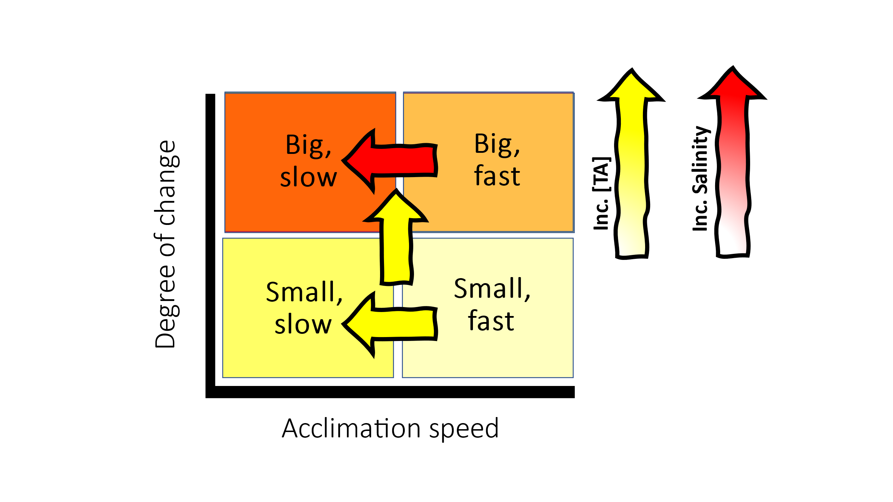

**Takeaways:**

* From our data, it appears that TA may be a factor for driving large increases in growth (relative to salinity/pH); however, when it comes to acclimation speed, TA only seems to have an effect when the degree of overall change is small. It is unsurprising that we see increases in TA lead to higher growth ratios over time due to HCO3- being used as a substrate, a higher concentration of bicarbonate may elevate the individual growth rates in treatments with high TA concentrations.
* However, it is interesting that TA only seems to be related to acclimation speeds in scenarios with smaller acclimation shift distances. Individuals exposed to ambient TA concentrations were able to acclimate to low salinity conditions and ambient salinity treatments quickly. WHY?
* Under high salinity conditions, we saw general acclimation speeds that were slower than in those exposed to low salinity. In fact, groups exposed to low salinity generally depicted complete acclimation by week 2, whereas two of the three groups exposed to high S conditions still showed acclimation occurring beyond week 2. WHY?
* although TA drives the degree of growth, individuals exposed to the multitude of stressors demonstrated faster physiological acclimation rates than those exposed to only a single axis of stress. WHY?
* Individuals in low TA are slow to acclimate to either S condition; suggests that low TA may disrupt salinity acclimation pathways